CSS QUESTION :

1 . Make a layout like this

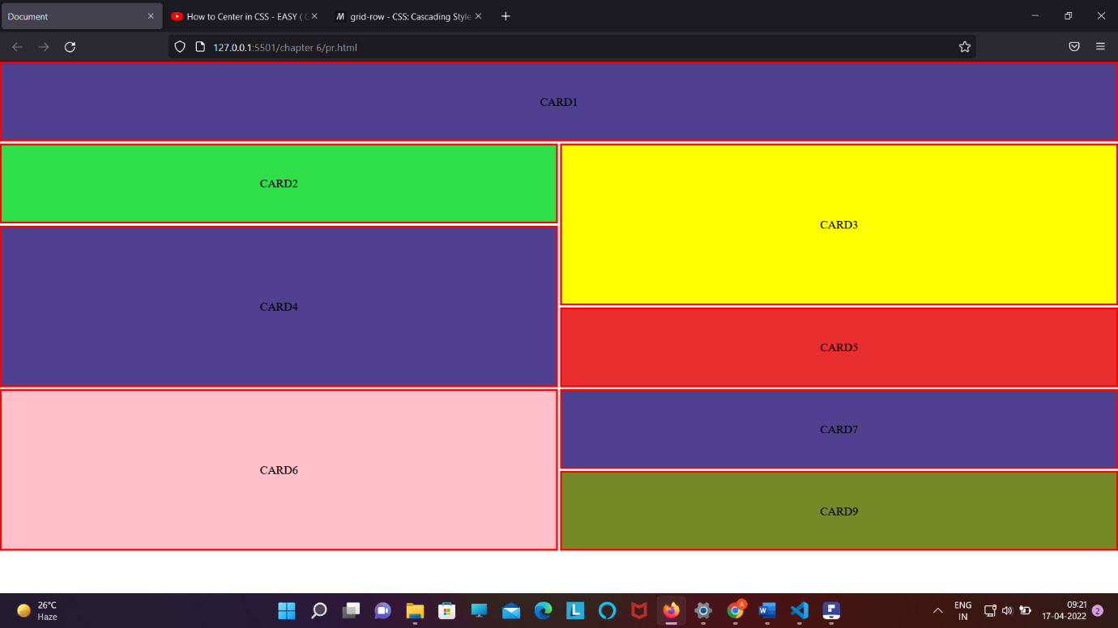

Code :

Html code :

<!DOCTYPE html>

<html lang="en">

<head>

    <meta charset="UTF-8">

    <meta http-equiv="X-UA-Compatible" content="IE=edge">

    <meta name="viewport" content="width=device-width, initial-scale=1.0">

    <title>Document</title>

    <link rel="stylesheet" href="pr.css">

</head>

<body>

<div class="container">

    <div class="box1">CARD1</div>

    <div class="box2">CARD2</div>

    <div class="box3">CARD3</div>

    <div class="box4">CARD4</div>

    <div class="box5">CARD5</div>

    <div class="box6">CARD6</div>

    <div class="box7">CARD7</div>

    <div class="box8">CARD8</div>

    <div class="box9">CARD9</div>

</div>

</body>

</html>

Css code :

* {

*padding*: 0;

*margin*: 0;

*box-sizing*: border-box;

}

.container {

*background-color*: white;

*height*: 100vh;

*margin*: auto;

*display*: grid;

*grid-template*: repeat(7, 15vh) / repeat(2, 1fr);

*grid-gap*: 3px;

*grid-template-areas*:

  "card1 card1"

  "card2 card3"

  "card4 card3"

  "card4 card5"

  "card6 card7"

  "card6 card8"

  "card9 card9"

  ;

}

.box1 {

*background-color*: rgb(80, 65, 144);

*border*: 3px solid red;

*display*: flex;

*align-items*: center;

*justify-content*: center;

*grid-area*: card1;

}

.box2 {

*background-color*: rgb(48, 224, 75);

*border*: 3px solid red;

*display*: flex;

*align-items*: center;

*justify-content*: center;

*grid-area*: card2;

}

.box3 {

*background-color*: yellow;

*border*: 3px solid red;

*display*: flex;

*align-items*: center;

*justify-content*: center;

*grid-area*: card3;

}

.box4 {

*background-color*: rgb(80, 65, 144);

*border*: 3px solid red;

*display*: flex;

*align-items*: center;

*justify-content*: center;

*grid-area*: card4;

}

.box5 {

*background-color*: rgb(232, 46, 46);

*border*: 3px solid red;

*display*: flex;

*align-items*: center;

*justify-content*: center;

*grid-area*: card5;

}

.box6 {

*background-color*: pink;

*border*: 3px solid red;

*display*: flex;

*align-items*: center;

*justify-content*: center;

*grid-area*: card6;

}

.box7 {

*background-color*: rgb(80, 65, 144);

*border*: 3px solid red;

*display*: flex;

*align-items*: center;

*justify-content*: center;

*grid-area*: card7;

}

.box8 {

*background-color*: orange;

*border*: 3px solid red;

*display*: flex;

*align-items*: center;

*justify-content*: center;

*grid-area*: card8;

}

.box9 {

*background-color*: rgb(119, 136, 39);

*border*: 3px solid red;

*display*: flex;

*align-items*: center;

*justify-content*: center;

*grid-area*: card8;

}

Q .2

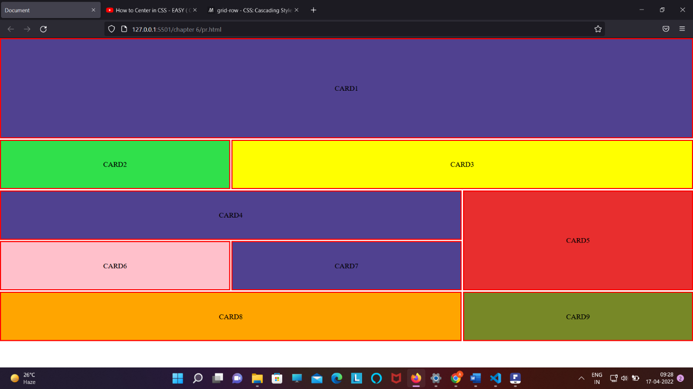

Code :

<!DOCTYPE html>

<html lang="en">

<head>

    <meta charset="UTF-8">

    <meta http-equiv="X-UA-Compatible" content="IE=edge">

    <meta name="viewport" content="width=device-width, initial-scale=1.0">

    <title>Document</title>

    <link rel="stylesheet" href="pr.css">

</head>

<body>

<div class="container">

    <div class="box1">CARD1</div>

    <div class="box2">CARD2</div>

    <div class="box3">CARD3</div>

    <div class="box4">CARD4</div>

    <div class="box5">CARD5</div>

    <div class="box6">CARD6</div>

    <div class="box7">CARD7</div>

    <div class="box8">CARD8</div>

    <div class="box9">CARD9</div>

</div>

</body>

</html>

Css code :

* {

*padding*: 0;

*margin*: 0;

*box-sizing*: border-box;

}

.container {

*background-color*: white;

*height*: 100vh;

*margin*: auto;

*display*: grid;

*grid-template*: repeat(7, 15vh) / repeat(3, 1fr);

*grid-gap*: 3px;

*grid-template-areas*:

  "card1 card1 card1"

  "card1 card1 card1"

  "card2 card3 card3"

  "card4 card4 card5"

  "card6 card7 card5"

  "card8 card8 card9"

  ;

}

.box1 {

*background-color*: rgb(80, 65, 144);

*border*: 3px solid red;

*display*: flex;

*align-items*: center;

*justify-content*: center;

*grid-area*: card1;

}

.box2 {

*background-color*: rgb(48, 224, 75);

*border*: 3px solid red;

*display*: flex;

*align-items*: center;

*justify-content*: center;

*grid-area*: card2;

}

.box3 {

*background-color*: yellow;

*border*: 3px solid red;

*display*: flex;

*align-items*: center;

*justify-content*: center;

*grid-area*: card3;

}

.box4 {

*background-color*: rgb(80, 65, 144);

*border*: 3px solid red;

*display*: flex;

*align-items*: center;

*justify-content*: center;

*grid-area*: card4;

}

.box5 {

*background-color*: rgb(232, 46, 46);

*border*: 3px solid red;

*display*: flex;

*align-items*: center;

*justify-content*: center;

*grid-area*: card5;

}

.box6 {

*background-color*: pink;

*border*: 3px solid red;

*display*: flex;

*align-items*: center;

*justify-content*: center;

*grid-area*: card6;

}

.box7 {

*background-color*: rgb(80, 65, 144);

*border*: 3px solid red;

*display*: flex;

*align-items*: center;

*justify-content*: center;

*grid-area*: card7;

}

.box8 {

*background-color*: orange;

*border*: 3px solid red;

*display*: flex;

*align-items*: center;

*justify-content*: center;

*grid-area*: card8;

}

.box9 {

*background-color*: rgb(119, 136, 39);

*border*: 3px solid red;

*display*: flex;

*align-items*: center;

*justify-content*: center;

*grid-area*: card9;

}

4 . making nav bar

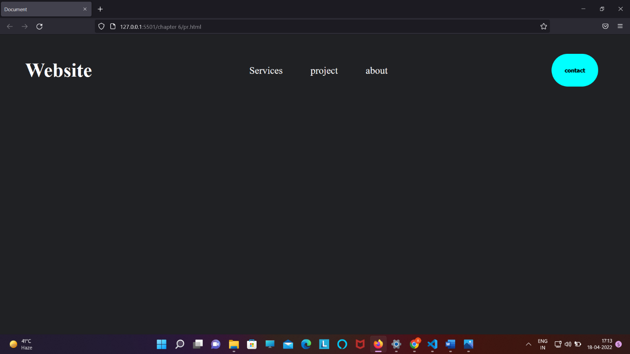

Code :

<!DOCTYPE html>

<html lang="en">

<head>

    <meta charset="UTF-8">

    <meta http-equiv="X-UA-Compatible" content="IE=edge">

    <meta name="viewport" content="width=device-width, initial-scale=1.0">

    <title>Document</title>

    <style>

        @import url("https://fonts.googleapis.com/css2?family=Bebas+Neue&family=Oswald:wght@200&family=Updock&display=swap");

        * {

*margin*: 0;

*padding*: 0;

*box-sizing*: border-box;

*background-color*: rgb(32, 33, 36);

        }

        header h1,

        a,

        button {

*color*: white;

        }

        header {

*display*: flex;

*justify-content*: space-between;

*align-items*: center;

*padding*: 2vw 4vw;

        }

        .nav_bar li,

        a {

*list-style*: none;

*display*: inline-block;

*text-decoration*: none;

*padding*: 1rem;

*font-size*: 1.5rem;

*cursor*: pointer;

        }

        .nav_bar li :hover {

*color*: aqua;

        }

        button {

*color*: black;

*border*: none;

*background-color*: aqua;

*border-radius*: 50px;

*padding*: 2rem;

*cursor*: pointer;

*font-weight*: bold;

        }

        button:hover {

*background-color*: aquamarine;

        }

        header h1 {

*font-size*: 3rem;

*cursor*: pointer;

        }

        .logo:hover {

*color*: aqua;

        }

    </style>

</head>

<body>

    <header>

        <h1 class="logo">Website</h1>

        <nav>

            <ul class="nav_bar">

                <li><a href="#">Services</a></li>

                <li><a href="#">project</a></li>

                <li><a href="#">about</a></li>

            </ul>

        </nav>

        <a href="#"><button>contact</button></a>

    </header>

</body>

</html>

5. Making a drop-down menu bar :

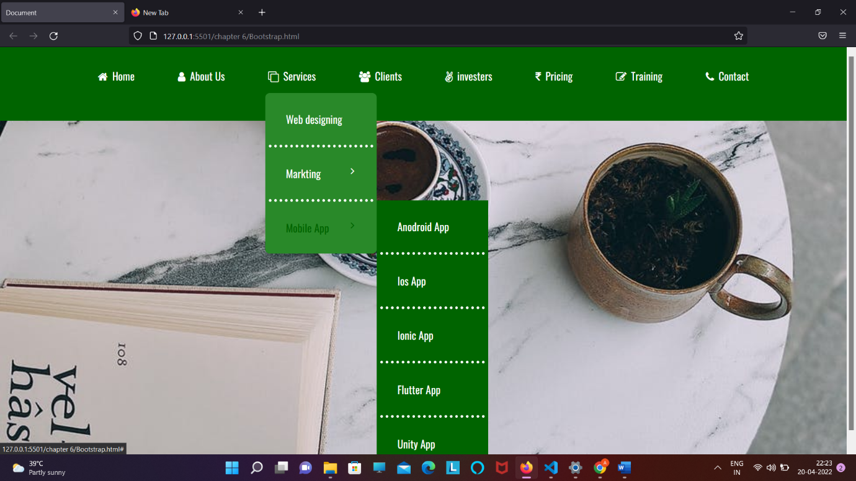

Html code :

<!DOCTYPE html>

<html lang="en">

<head>

    <meta charset="UTF-8">

    <meta http-equiv="X-UA-Compatible" content="IE=edge">

    <meta name="viewport" content="width=device-width, initial-scale=1.0">

    <title>Document</title>

    <link rel="stylesheet" href="bootstrap.css">

    <link rel="stylesheet" href="https://cdnjs.cloudflare.com/ajax/libs/font-awesome/4.7.0/css/font-awesome.min.css">

</head>

<body>

    <header class="menubar">

        <nav>

            <ul class="nav_bar">

                <li><a href="#"><i class="fa fa-home"></i>Home</a></li>

                <li><a href="#"><i class="fa fa-user"></i>About Us</a>

                    <div class="sub-menu-1">

                        <ul>

                            <li><a href="#">Mission</a></li>

                            <li><a href="#">Vision</a></li>

                            <li><a href="#">Team</a></li>

                        </ul>

                    </div></li>

                <li><a href="#"><i class="fa fa-clone"></i>Services</a>

                    <div class="sub-menu-1">

                        <ul>

                            <li><a href="#">Web designing</a></li>

                            <li class="hover-Me"><a href="#">Markting<i  class="fa fa-angle-right"></i></a>

                              <div class="sub-menu-2">

                                  <ul>

                                      <li><a href="#">SEO</a></li>

                                      <li><a href="#">Social Media</a></li>

                                      <li><a href="#">Email Marketing</a></li>

                                  </ul>

                              </div>

                            </li>

                            <li class="hover-Me"><a href="#">Mobile App<i  class="fa fa-angle-right"></i></a>

                                <div class="sub-menu-2">

                                    <ul>

                                        <li><a href="#">Anodroid App</a></li>

                                        <li><a href="#">Ios App</a></li>

                                        <li><a href="#">Ionic App</a></li>

                                        <li><a href="#">Flutter App</a></li>

                                        <li><a href="#">Unity App</a></li>

                                    </ul>

                                </div>

                            </li>

                        </ul>

                </li>

                <li><a href="#"><i class="fa fa-users"></i>Clients</a></li>

                <li><a href="#"><i class="fa fa-angellist"></i>investers</a></li>

                <li><a href="#"><i class="fa fa-inr"></i>Pricing</a></li>

                <li><a href="#"><i class="fa fa-edit"></i>Training</a></li>

                <li><a href="#"><i class="fa fa-phone"></i>Contact</a></li>

            </ul>

        </nav>

    </header>

</body>

</html>

Css code :

@import url("https://fonts.googleapis.com/css2?family=Oswald:wght@200;300;400&display=swap");

* {

*margin*: 0;

*padding*: 0;

*box-sizing*: border-box;

}

body {

*font-family*: "Oswald", sans-serif;

*background*: url("https://images.pexels.com/photos/11378257/pexels-photo-11378257.jpeg?auto=compress&cs=tinysrgb&dpr=2&h=650&w=940")

    center;

*background-size*: cover;

}

.nav_bar {

*height*: 18vh;

*background*: rgb(0, 100, 0);

*text-align*: center;

}

.nav_bar li a {

*font-size*: 1.2rem;

  /* list-style: none; */

*text-decoration*: none;

*color*: white;

*padding*: 5px;

}

.nav_bar li {

*display*: inline-flex;

*padding*: 2rem;

*cursor*: pointer;

}

.nav_bar li :hover {

*background-color*: rgb(41, 137, 41);

*border-radius*: 8px;

}

.nav_bar .fa {

*margin-right*: 8px;

}

.sub-menu-1 {

*display*: none;

}

.menubar ul li:hover .sub-menu-1 {

*display*: block;

*position*: absolute;

*background-color*: rgb(0, 100, 0);

*margin-top*: 50px;

}

.menubar ul li:hover .sub-menu-1 ul li {

*display*: block;

*width*: 200px;

*border-bottom*: 5px dotted white;

*cursor*: pointer;

*text-align*: left;

}

.menubar ul li:hover .sub-menu-1 ul li:last-child {

*border-bottom*: none;

}

.sub-menu-1 li :hover {

*color*: rgb(0, 100, 0);

}

.fa-angle-right {

*float*: right;

}

.sub-menu-2 {

*display*: none;

}

.hover-Me:hover .sub-menu-2 {

*display*: block;

*position*: absolute;

*background-color*: rgb(0, 100, 0);

*margin-left*: 168px;

*margin-top*: -63px;

}

Q. Make a responsive website ;

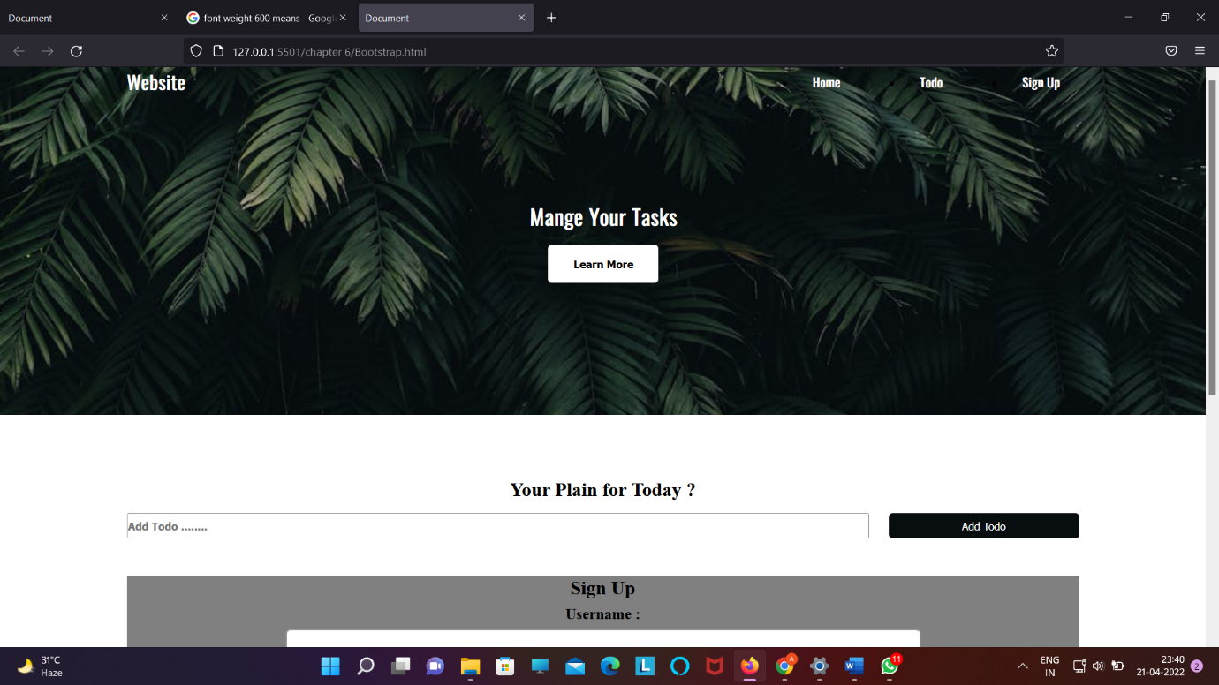

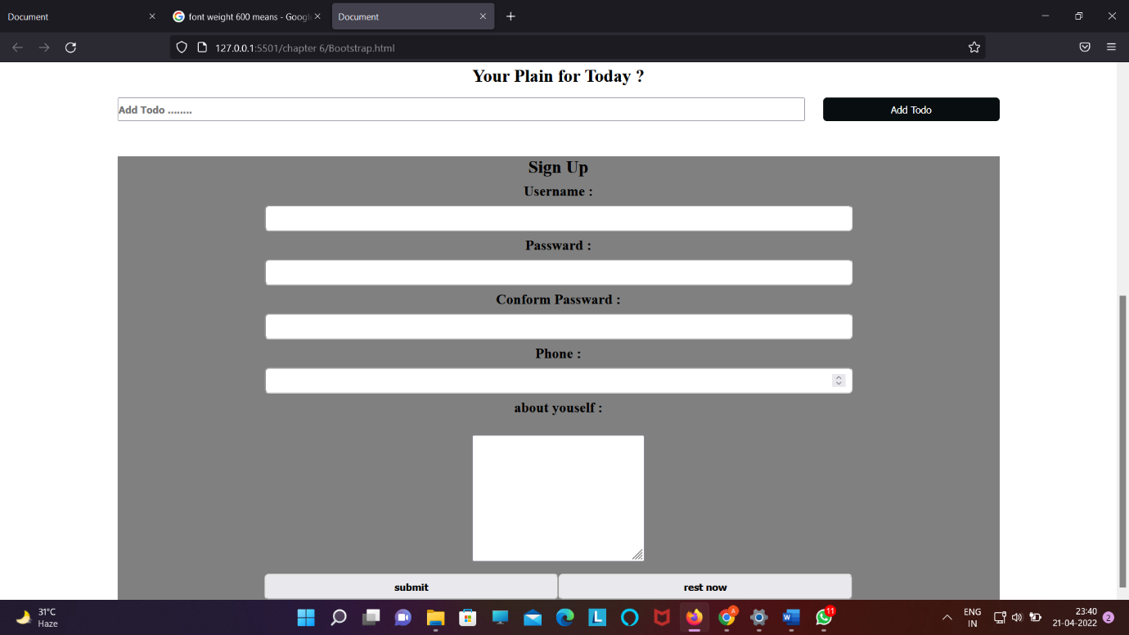

Html code :

<!DOCTYPE html>

<html lang="en">

<head>

    <meta charset="UTF-8">

    <meta http-equiv="X-UA-Compatible" content="IE=edge">

    <meta name="viewport" content="width=device-width, initial-scale=1.0">

    <title>Document</title>

    <link rel="stylesheet" href="bootstrap.css">

</head>

<body>

    <header class="header">

        <nav class="nav container">

            <h1 class="logo">Website</h1>

            <ul class="nav-items">

                <li><a href="#">Home</a></li>

                <li><a href="#">Todo</a></li>

                <li><a href="#">Sign Up</a></li>

            </ul>

        </nav>

        <div class="write-up">

            <h1 class="heading">Mange Your Tasks</h1>

            <button class="btn btn-headline">Learn More</button>

        </div>

    </header>

    <section class="section-todo container">

        <h1>Your Plain for Today ?</h1>

        <form class="form-todo">

            <input type="text" class="todo=text" placeholder="Add Todo ........">

            <input type="submit" value="Add Todo" class="btn">

        </form>

    </section>

    <section class="section-signup container">

        <h1>Sign Up</h1>

        <form class="form-singnup">

            <div class="signup-items">

                <label for="username">Username : </label>

                <input type="text" id="username" name="username">

            </div>

            <div class="signup-items">

                <label for="passward">Passward : </label>

                <input type="password" id="passward" name="passward">

            </div>

            <div class="signup-items">

                <label for="Conform Passward">Conform Passward : </label>

                <input type="password" id="Conform Passward" name="Conform Passward">

            </div>

            <div class="signup-items">

                <label for="Phone ">Phone : </label>

                <input type="number" id="Phone " name="Phone ">

            </div>

            <div class="signup-items">

                <label for="about">about youself :</label><br>

                <textarea name="about" id="about" cols="30" rows="10"></textarea>

            </div>

            <div class="submit-reset">

                <input type="submit" value="submit">

                <input type="reset" value="rest now">

        </form>

        </div>

    </section>

</body>

</html>

Css code :

@import url("https://fonts.googleapis.com/css2?family=Oswald:wght@200;300;400&display=swap");

* {

*margin*: 0;

*padding*: 0;

*box-sizing*: border-box;

}

.header {

*position*: relative;

*min-height*: 60vh;

*background*: url("https://images.pexels.com/photos/1072179/pexels-photo-1072179.jpeg?auto=compress&cs=tinysrgb&w=1260&h=750&dpr=1")

    no-repeat center;

*background-size*: cover;

*font-family*: "Oswald", sans-serif;

}

header .logo,

a {

*color*: white;

}

.container {

*max-width*: 1200px;

*margin*: auto;

*width*: 90%;

}

.nav {

*text-align*: center;

*display*: flex;

*justify-content*: space-between;

*align-items*: center;

*font-weight*: bold;

}

.nav-items {

*min-width*: 30%;

*display*: inline-flex;

*justify-content*: space-between;

}

.nav-items a {

*text-decoration*: none;

}

.heading {

*color*: white;

*font-size*: 1.7rem;

}

.write-up {

*position*: absolute;

*top*: 50%;

*left*: 50%;

*text-align*: center;

*transform*: translate(-50%, -50%);

}

.btn {

*border*: none;

*display*: inline-block;

*outline*: none;

*cursor*: pointer;

}

.btn-headline {

*margin-top*: 1rem;

*padding*: 1rem 2rem;

*background-color*: white;

*font-weight*: bold;

*border-radius*: 5px;

}

.nav-items li:hover {

*background-color*: rgb(105, 234, 73);

*border-radius*: 5px;

}

.nav-items a {

*padding*: 1rem 1.5rem;

}

.section-todo {

*text-align*: center;

*margin-top*: 5rem;

}

.form-todo {

*min-height*: 2rem;

*margin-top*: 1rem;

*display*: flex;

*justify-content*: space-between;

}

.form-todo input[type="text"] {

*min-width*: 78%;

*font-weight*: 600;

*color*: black;

}

.form-todo input[type="submit"] {

*min-width*: 20%;

*background-color*: #080d10;

*color*: white;

*border-radius*: 5px;

}

.form-todo input[type="submit"]:hover {

*background-color*: rgb(105, 234, 73);

}

.section-signup {

*margin-top*: 3rem;

*background-color*: grey;

*text-align*: center;

}

.section-signup label,

input {

*display*: block;

}

.form-singnup {

*max-width*: 800px;

*width*: 95%;

*margin*: auto;

}

.form-singnup input {

*width*: 100%;

*padding*: 0.5rem;

*border-radius*: 5px;

}

.form-singnup label {

*font-weight*: bold;

*margin*: 0.5rem;

*font-size*: 1.2rem;

}

.submit-reset{

*margin-top*: 1rem;

*display*: flex;

*justify-content*: space-between;

}

.submit-reset input[type="submit"] ,input[type="reset"]{

*font-weight*: bold;

}

section-signup:last-child{

*margin-bottom*: 2rem;

}

Q .



Html code –

<!DOCTYPE html>

<html lang="en">

<head>

    <meta charset="UTF-8" />

    <meta http-equiv="X-UA-Compatible" content="IE=edge" />

    <meta name="viewport" content="width=device-width, initial-scale=1.0" />

    <title>Document</title>

    <link rel="stylesheet" href="pr.css" />

    <link rel="stylesheet" href="https://cdnjs.cloudflare.com/ajax/libs/font-awesome/4.7.0/css/font-awesome.min.css" />

</head>

<body>

    <header class="header">

        <nav class="nav container">

            <h1 class="logo">ParRoz</h1>

            <ul class="nav-items">

                <li><a href="#">Home</a></li>

                <li><a href="#">about</a></li>

                <li><a href="#">Service</a></li>

                <li><a href="#">Design</a></li>

                <li><a href="#">Contact</a></li>

            </ul>

            <div class="search-box">

                <input type="search" name="search" placeholder="Type to Text" />

                <button class="btn btn-heading">search</button>

            </div>

        </nav>

    </header>

    <section class="section-header">

        <div class="heading">

            <div class="section-items">

                <h1>Web Design &<br><span>Development</span><br>Course</h1>

            </div>

            <div class="para">

                <p>Lorem ipsum dolor, sit amet consectetur adipisicing elit. Consequatur officiis voluptate ipsam

                    debitis provident non<br> assumenda sed, harum ducimus voluptates rem! Doloremque, saepe nobis

                    facilis

                    iste cum eum sed illo. Quisquam nisi,<br> eligendi impedit saepe distinctio nobis similique a odio!

                </p>

            </div>

            <a class="section-btn" href="#"><button class="btn">JOIN US</button></a>

        </div>

        <div class="login-btn">

            <h2>Login Here</h2>

            <div class="login-email">

                <input type="email"" name=" email" placeholder="Enter Email Here">

            </div>

            <div class="login-passward">

                <input type="password" name="password" placeholder="Enter Password Here">

            </div>

            <div class="login-button">

                <a href="#"><button class="btn">login</button></a>

            </div>

            <div class="signup">

                <h1>Don't have account<br><span>Sign UP</span> Here</h1>

            </div>

            <div class="icons">

                <a href="#">

                    <ion-icon name="logo-facebook"></ion-icon>

                </a>

                <a href="#">

                    <ion-icon name="logo-instagram"></ion-icon>

                </a>

                <a href="#">

                    <ion-icon name="logo-twitter"></ion-icon>

                </a>

                <a href="#">

                    <ion-icon name="logo-google"></ion-icon>

                </a>

                <a href="#">

                    <ion-icon name="logo-skype"></ion-icon>

                </a>

            </div>

        </div>

    </section>

    <script src="https://unpkg.com/ionicons@5.4.0/dist/ionicons.js"></script>

</body>

</html>

Css / bootstrap –

@import url("https://fonts.googleapis.com/css2?family=Oswald:wght@200;300;400&display=swap");

* {

*margin*: 0;

*padding*: 0;

*box-sizing*: border-box;

}

body {

*background*: linear-gradient(

      to top,

      rgba(0, 0, 0, 0.5) 50%,

      rgba(0, 0, 0, 0.5) 50%

    ),

    url("image.jpg") no-repeat center;

*background-size*: cover;

*min-height*: 110vh;

}

.header {

*min-height*: 20vh;

*background*: linear-gradient(

    to top,

    rgba(0, 0, 0, 0.5) 50%,

    rgba(0, 0, 0, 0.5) 50%

  );

*font-family*: Arial;

*position*: sticky;

*top*: 0;

}

.container {

*max-width*: 1350px;

*margin*: auto;

*width*: 90%;

}

.nav {

*text-align*: center;

*display*: flex;

*justify-content*: space-between;

*justify-items*: center;

}

.nav-items {

*min-width*: 50%;

*display*: inline-flex;

*justify-content*: space-between;

}

.nav-items,

.search-box {

*height*: 5rem;

*position*: relative;

}

.logo,

.nav-items li,

.search-box input,

.search-box button {

*margin-top*: 2rem;

}

.nav-items li a {

*list-style*: none;

*text-decoration*: none;

*color*: white;

*text-transform*: uppercase;

*font-weight*: bolder;

*transition*: 0.3s ease-in;

}

.logo {

*color*: orange;

*font-weight*: bold;

*font-size*: 2rem;

}

.nav-items li a:hover {

*color*: orange;

}

.btn {

*display*: inline-block;

*border*: none;

*outline*: none;

*cursor*: pointer;

}

.search-box {

*min-width*: 30%;

*display*: inline-flex;

*justify-content*: space-between;

}

.search-box input {

*min-width*: 75%;

*background*: linear-gradient(

    to top,

    rgba(0, 0, 0, 0.8) 50%,

    rgba(0, 0, 0, 0.8) 50%

  );

*color*: white;

*font-weight*: bold;

*margin-bottom*: 1rem;

}

.search-box button {

*min-width*: 25%;

*margin-bottom*: 1rem;

*background-color*: orange;

*color*: white;

*font-weight*: bold;

*cursor*: pointer;

*transition*: 0.3s ease-in;

}

.search-box button:hover {

*background-color*: white;

*color*: orange;

}

.section-header {

*position*: relative;

*top*: 15vh;

*max-width*: 1400px;

*min-height*: 70vh;

*margin*: auto;

*width*: 90%;

*display*: flex;

*justify-content*: space-between;

}

.heading {

*min-width*: 60%;

*font-family*: Arial;

*max-width*: 60%;

}

.login-btn {

*min-width*: 30%;

*font-family*: Arial;

*text-align*: center;

*background*: linear-gradient(

    to top,

    rgba(0, 0, 0, 0.8) 50%,

    rgba(0, 0, 0, 0.8) 50%

  );

}

.section-items {

*margin-top*: 3rem;

*color*: white;

*font-size*: 2.5rem;

*font-weight*: bold;

}

.section-items span {

*color*: orange;

}

.para {

*margin-top*: 1rem;

*color*: white;

*font-weight*: bold;

*line-height*: 1.5rem;

*letter-spacing*: 0.1rem;

}

.section-btn button {

*margin-top*: 1rem;

*color*: white;

*background-color*: orange;

*padding*: 1rem 2rem;

*font-weight*: bold;

*font-family*: Arial;

*border-radius*: 5px;

*cursor*: pointer;

*transition*: 0.3s ease-in;

}

.section-btn button:hover {

*color*: darkorange;

*background-color*: white;

}

.login-btn h2 {

*margin-top*: 3rem;

*margin-left*: 5rem;

*margin-right*: 5rem;

*color*: orange;

*background-color*: white;

*padding*: 0.6rem;

*border-radius*: 5px;

*margin-bottom*: none;

}

.login-email input,

.login-passward input {

*background*: linear-gradient(

    to top,

    rgba(0, 0, 0, 0.4) 50%,

    rgba(0, 0, 0, 0.4) 50%

  );

*border*: none;

*font-size*: 1.5rem;

*color*: white;

*margin-top*: 2rem;

*text-align*: left;

*margin-bottom*: 1rem;

*border-bottom*: 2px solid brown;

}

.login-button button {

*margin-top*: 2rem;

*background-color*: orange;

*color*: black;

*font-size*: 1rem;

*padding*: 1rem 3rem;

*border-radius*: 6px;

*font-weight*: bold;

*font-family*: Arial;

*cursor*: pointer;

*transition*: 0.3s ease-in;

}

.login-button button:hover {

*background-color*: white;

*color*: darkorange;

}

.signup{

*margin-top*: 1rem;

*color*: white;

}

.signup span{

*color*: orange;

}

ion-icon{

*color*: white;

*margin-top*: 0.5rem;

*padding*: 1rem;

*cursor*: pointer;

*transition*: 0.3s ease-in;

*font-size*: 2rem;

}

ion-icon:hover{

*color*: orange;

}